Sentiment Analysis of Amazon Product Reviews Using Text Mining and Machine Learning

Tung Tran, Mansi Sanjay Bhosle, Hindolo Dominic Magbity
Team 02
DS515: Data Science Overview
MS in Data Science
School of Technology and Computing
City University of Seattle
trantung@cityuniversity.edu
bhoslemansisanjay@cityuniversity.edu
magbityhindolodomin@cityuniversity.edu

Abstract

This project applies the data science project life cycle to analyze customer sentiment expressed in Amazon product reviews. The Amazon Fine Food Reviews data set obtained from Kaggle serves as the primary resource for conducting an analysis of customer sentiment using unstructured textual data related to products. In line with the key procedures in the data science process (Defining the problem, acquiring the data, cleaning the data, creating features, modelling, evaluating, and visualizing the data), this analysis will employ several text analysis methods, including tokenization and TF-IDF to convert customer review text into numerical features. Supervised learning algorithms (Naive Bayes and Logistic Regression) will be used to classify review ratings and thus customer sentiment from customer reviews. In addition, unsupervised learning techniques (i.e., topic modelling) will be used to identify common themes from the feedback given to the business, and visualization methods (i.e., word clouds and distribution of sentiment plots) will also be incorporated in the overall summarization of results. The results of this study provide valuable insights for organizations that are able to use the power of text analytics and machine learning to gain data-driven insights into their decision-making process.

Keywords: Sentiment Analysis, Text Mining, Amazon Product Reviews, Machine Learning, TF-IDF, Naïve Bayes, Logistic Regression, Topic Modeling

1. INTRODUCTION

1.1. Background and Problem Statement
Consumers’ interaction with businesses has changed dramatically due to the rapid rise of e-commerce. Today, online platforms, such as Amazon, contain billions of product reviews and provide an enormous source of user-generated content containing real customer opinions, preferences, and experiences. In a survey conducted by Chen et al. (2022), it was found that 93% of consumers are impacted by online reviews; and 82% read them before making final purchase decisions. Power Reviews' survey of 2023 demonstrated that ratings and reviews are more valuable to consumers than price, free shipping, or brand name as a purchasing criteria. This marks a significant change in consumer behaviour as customers increasingly depend on peer feedback to make purchase decisions, rather than traditional advertising.
Despite the vast amount of review data available today, many organizations have difficulty extracting meaningful and timely insights from that data. Manually reading and categorizing thousands, or millions, of reviews is not practical on a large scale. Consequently, there exists a considerable disparity between the volume of data that businesses have and the actionable intelligence they derive from it. Therefore, the overarching business problem this project addresses is: What do customers actually feel about products, and how can this be measured systematically and at scale?

1.2. Significance, Methodology, and Scope
Gaining insight into how customers feel about products and brands means much more than gathering customers’ comments or feedback. If businesses can accurately understand how customers feel about their products or services, they can enhance product quality, protect brand image and respond better to changing marketplace conditions. The influence of customer sentiment on revenue is evidenced by research showing that even just improving an overall product rating by one star can create quantifiable revenue growth (WiserNotify 2024). However, because customer reviews are unstructured and are written using informal language, they can create significant challenges when businesses attempt to perform analysis on this type of data. Wankhade et al. (2022) defined sentiment analysis as the activity of extracting and analyzing customer opinions about products and services. Wankhade et al. also note the current challenges associated with accurately finding customer sentiment in various languages. To address these challenges, businesses can utilize Natural Language Processing (NLP) and machine learning techniques such as Term Frequency-Inverse Document Frequency (TF-IDF) based feature extraction and supervised algorithms, such as Naive Bayes and Logistic Regression for classification of sentiment. Unsupervised machines learning methods (such as Latent Dirichlet Allocation) can also be used by businesses to discover hidden themes within customer reviews and provide an understanding of what causes a customer to feel a certain way about a product, and the attributes or features of the product that caused the customer to form that opinion.
This project applies the data science lifecycle to analyze the Amazon Reviews Dataset from Kaggle (Dongrelaxman 2024), which contains product review text, star ratings, product information, and reviewer statistics. An overall star rating will be converted to a sentiment label (1-2 negative, 3 neutral, and 4-5 positive) to create the basis for a supervised classification project. The objectives of this project are to; classify sentiment using supervised machine learning models based on TF-IDF, identify recurring themes in the data using LDA topic modeling, and visualize sentiment patterns to support business decisions. The integration of both supervised and unsupervised methods of analysis demonstrates how businesses can use text analytics to convert raw, user-generated content into usable insights.

2. LITERATURE REVIEW
Pang and Lee (2008) created the main concepts in the area of computational sentiment analysis, and proved that by using supervised machine learning with product review text, it is possible to achieve accuracy at a higher level than using keyword based techniques, and demonstrated that there is an effect on classification accuracy based on the feature engineering choices made when using TF-IDF weighting to represent features. Wankhade et al. (2022) continue to support the findings of Pang and Lee by reporting on a more recent study confirming that TF-IDF is effective at representing text, while also identifying persistent issues in the area of sentiment analysis, such as the imbalance of classes and difficulties associated with identifying negation and sarcasm in informal reviews, both of which will have to be accounted for in this project at the time of pre-processing.
The modelling methodology used in this study is informed by Wang and Manning (2012), who compared the performance of the Naive Bayes and Logistic Regression models in sentiment classification tasks and provide justification for the modelling methodologies used in this project, as well as by McAuley and Leskovec (2013), who utilize Amazon review data to demonstrate that topics produced using LDA align with dimensions of products as identified by consumers, validating the use of topic modelling methodologies to identify items such as packaging, delivery and value to consumers from customer reviews. The unsupervised modelling approach is informed by Blei et al. (2003), who developed LDA as a generative model that can be used to uncover latent thematic structures within large volumes of text data and can be utilized to model data without labelled training data. Additionally, Chen et al. (2022) found that the content of the text in reviews is the primary factor that drives purchase decisions for consumers, as opposed to simply evaluating the star rating provided by consumers, which further demonstrates the business relevance of the combined analytical approach proposed through the research conducted in this study.

3. METHODOLOGY
This study follows a structured data science workflow to perform sentiment analysis on Amazon product reviews. The methodology integrates data preprocessing, feature engineering, supervised learning models, and unsupervised topic modeling to extract both predictive and interpretive insights.

3.1. Data Preprocessing
The dataset consists of unstructured textual data in the form of customer reviews. To prepare the data for analysis, several preprocessing steps were applied:
- Conversion of text to lowercase
- Removal of punctuation and special characters
- Elimination of stopwords
- Tokenization of text into individual words
- Removal of irrelevant or sparse terms
These steps reduced noise and improved the quality of input data for modeling.

3.2. Feature Extraction
The TF-IDF (Term Frequency–Inverse Document Frequency) technique was used to convert textual data into a numerical form.
TF-IDF assigns importance to words based on their frequency within a document and across the dataset, allowing the model to focus on meaningful terms while minimizing the influence of common but less informative words.

3.3. Sentiment Labeling
To enable supervised learning, sentiment labels were derived from product ratings:
- Ratings 1–2 → Negative
- Rating 3 → Neutral
- Ratings 4–5 → Positive
This transformed the problem into a multi-class classification task.

3.4. Model Development
Two machine learning models were implemented:
- Naïve Bayes: A probabilistic model effective for text classification
- Logistic Regression: A linear model that estimates class probabilities
The dataset was split into training and testing sets to evaluate model performance.

3.5. Model Evaluation
Model performance was assessed using:
- Accuracy
- Kappa statistic
- Confusion matrix
- Precision, Recall, and F1-score
These metrics provided a comprehensive evaluation of classification performance.

3.6. Topic Modeling (LDA)
Latent Dirichlet Allocation (LDA) was used to identify hidden topics within the review data. This helped uncover common themes such as delivery issues, customer service, and product experience, providing deeper insights beyond sentiment classification.

4. DATA
The dataset used in this study is the Amazon Fine Food Reviews dataset, obtained from Kaggle. It contains a large collection of customer reviews along with associated metadata.
Key features include:
- Review text
- Product ratings
- Reviewer information
The dataset is primarily unstructured, requiring preprocessing before analysis.
Sentiment labels were derived from rating scores, enabling the dataset to be used for supervised learning. Due to its textual nature and class distribution, the dataset presents challenges such as class imbalance, particularly with fewer neutral reviews compared to positive and negative ones.

5. RESULTS

5.1. Sentiment Distribution
The dataset exhibited a noticeable imbalance, with positive and negative reviews dominating over neutral reviews. This imbalance influenced model performance, particularly for the neutral class.
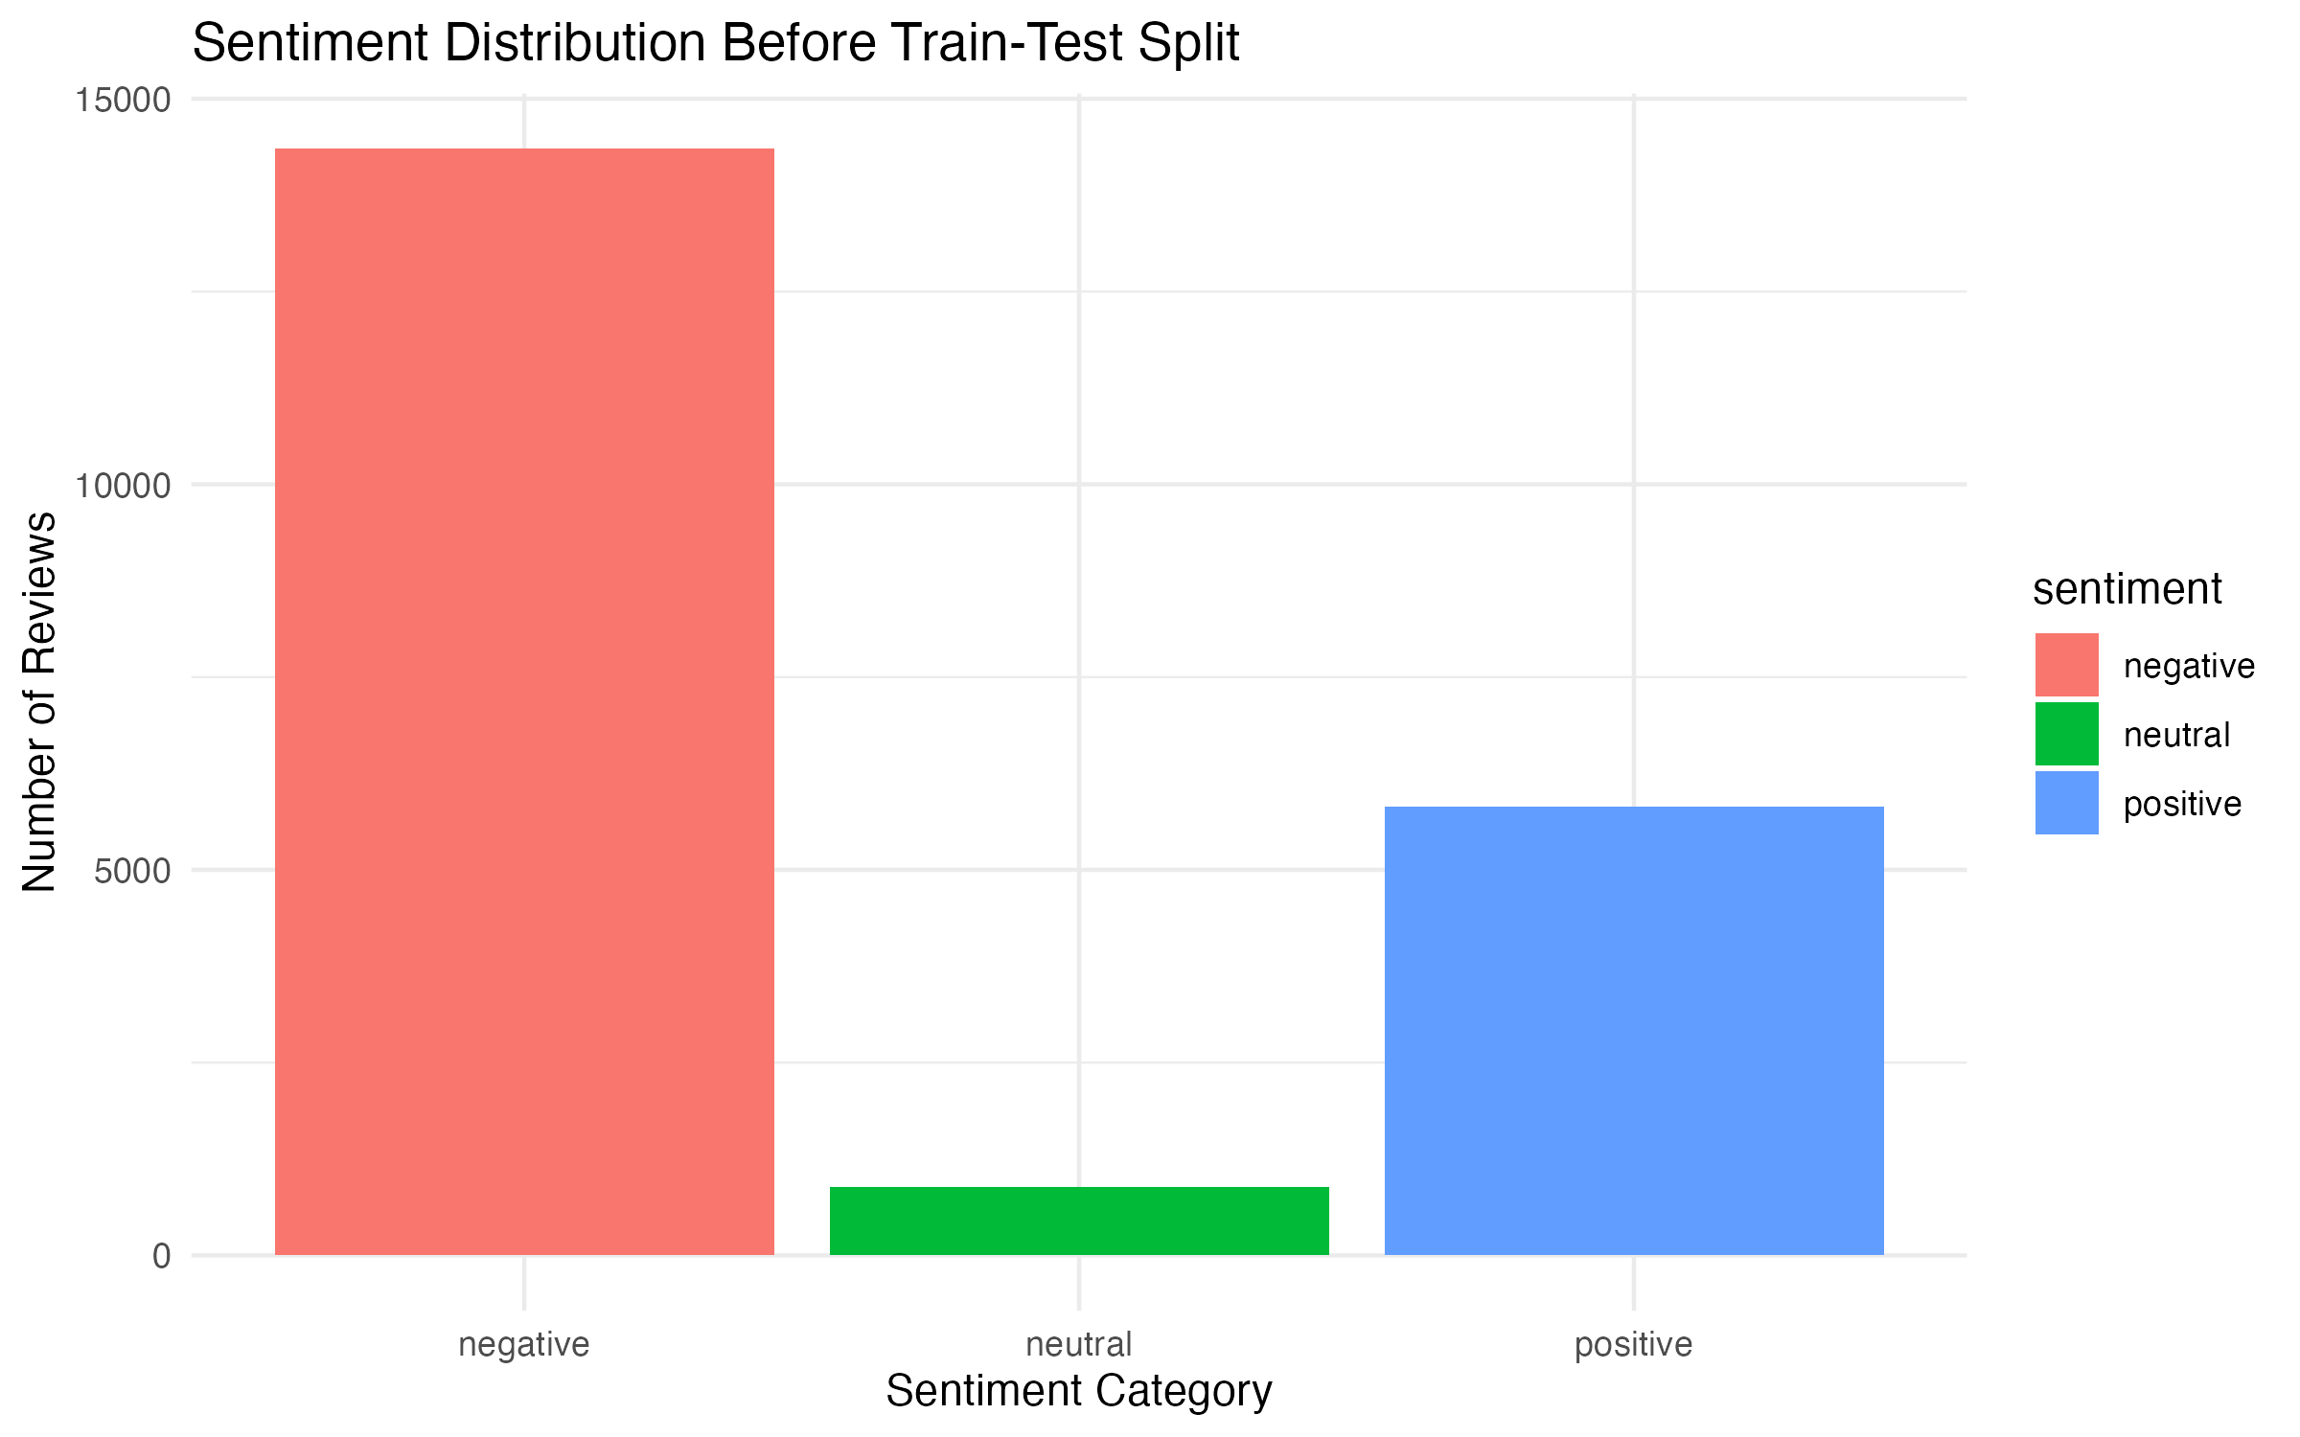Fig 1: Sentiment Distribution

5.2. Naïve Bayes Performance
The Naïve Bayes model performed well overall, significantly outperforming the baseline. It demonstrated strong performance in classifying positive and negative reviews but showed moderate difficulty with neutral sentiment.
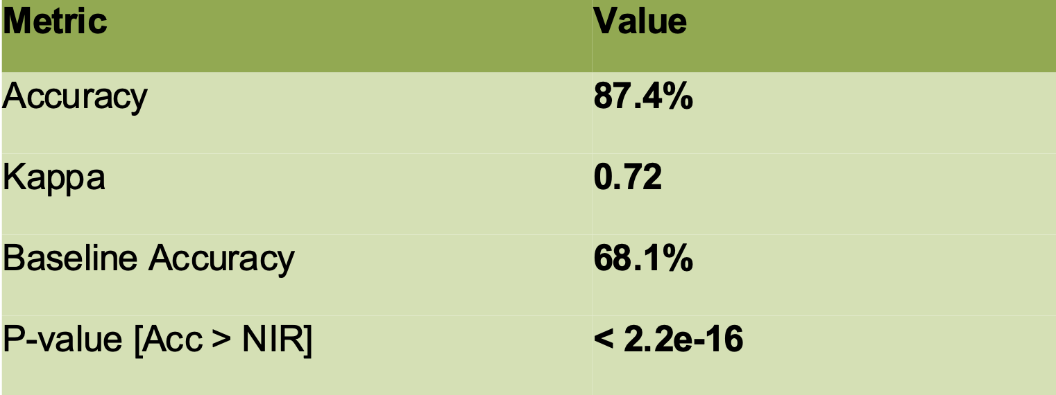

5.3. Logistic Regression Performance
Logistic Regression also performed well but slightly underperformed compared to Naïve Bayes. The model struggled significantly with the neutral class, showing very low recall.
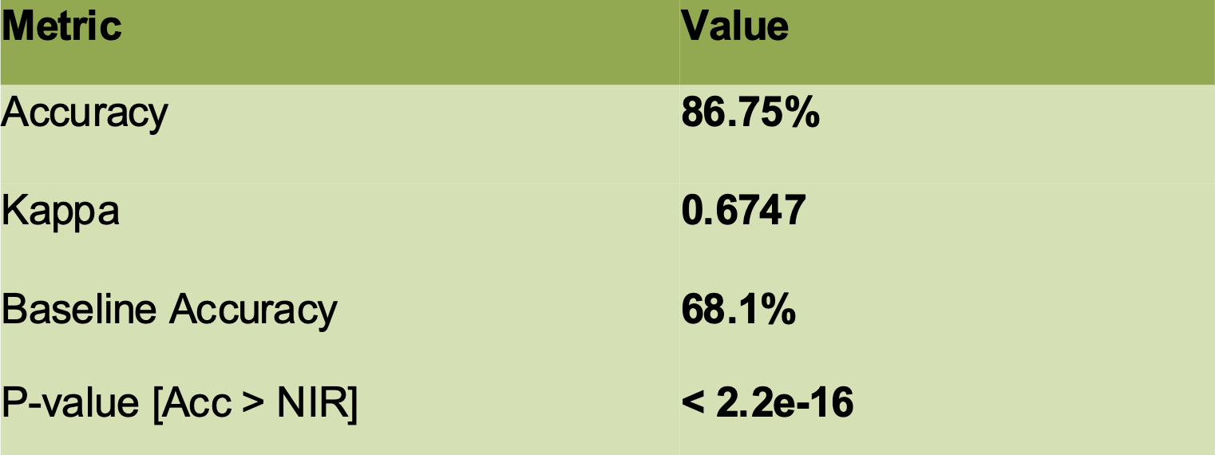

5.4. Model Comparison
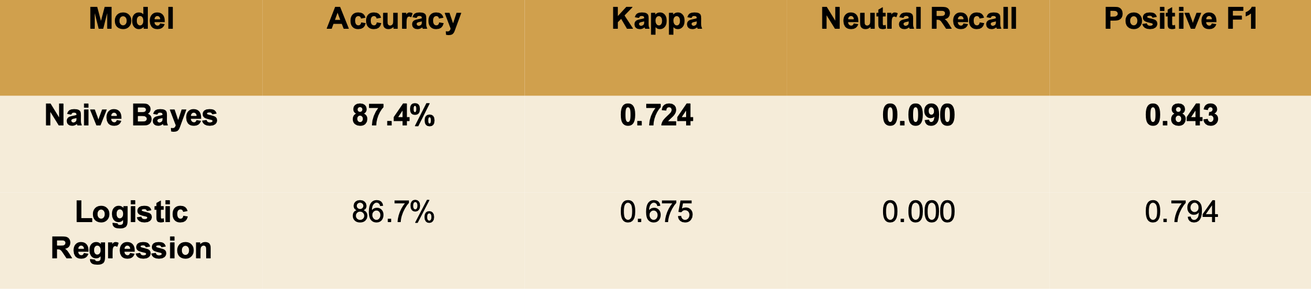
- Both models achieved high accuracy (>86%)
- Naïve Bayes slightly outperformed Logistic Regression
- Both models struggled with neutral sentiment classification
This highlights the impact of class imbalance and the complexity of identifying neutral sentiment in text data.

5.5. Topic Modeling Insights
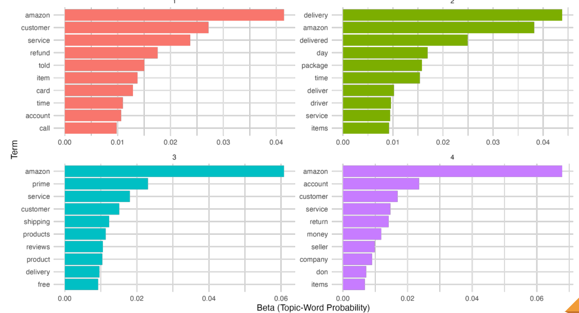
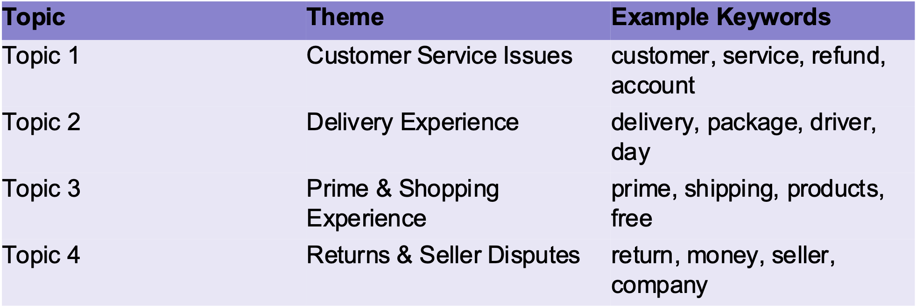
LDA revealed several key themes in customer reviews:
- Customer service issues
- Delivery and shipping experience
- Product quality and usage
- Returns and refunds
These insights provide valuable context behind customer sentiment and help explain model predictions.

6. CONCLUSION
This project demonstrates the effectiveness of machine learning techniques in analyzing customer sentiment from unstructured textual data. Both Naïve Bayes and Logistic Regression models achieved strong performance, confirming their suitability for text classification tasks.
However, the study also highlights key challenges, particularly in classifying neutral sentiment due to class imbalance and subtle language patterns.
The integration of topic modeling provided additional value by uncovering the underlying reasons behind customer opinions, offering deeper business insights.
Overall, sentiment analysis proves to be a powerful tool for organizations, enabling them to:
- Monitor customer satisfaction
- Identify recurring issues
- Improve products and services
Future work could explore advanced models such as deep learning approaches (e.g., LSTM, BERT) and improved techniques for handling class imbalance.
- REFERENCES
Chen, X., Samaranayake, P., Cen, X., Qi, M., & Lan, Y. (2022). The impact of online reviews on consumers' purchasing decisions: Evidence from an eye-tracking study. Frontiers in Psychology, 13, 865702. https://doi.org/10.3389/fpsyg.2022.865702
Dongrelaxman. (2024). Amazon reviews dataset: A comprehensive review dataset for e-commerce analysis [Data set]. Kaggle. https://www.kaggle.com/datasets/dongrelaxman/amazon-reviews-dataset
PowerReviews. (2023). Survey: The ever-growing power of reviews (2023 edition). https://www.powerreviews.com/power-of-reviews-2023/
Wankhade, M., Rao, A. C. S., & Kulkarni, C. (2022). A survey on sentiment analysis methods, applications, and challenges. Artificial Intelligence Review, 55, 5731–5780. https://doi.org/10.1007/s10462-022-10144-1
WiserNotify. (2024). 77 shocking online review statistics (new 2025 data). https://wisernotify.com/blog/online-review-stats/
Blei, D. M., Ng, A. Y., & Jordan, M. I. (2003). Latent Dirichlet allocation. Journal of Machine Learning Research, 3, 993–1022.
McAuley, J., & Leskovec, J. (2013). Hidden factors and hidden topics: Understanding rating dimensions with review text. Proceedings of the 7th ACM Conference on Recommender Systems, 165–172. https://doi.org/10.1145/2507157.2507163
Pang, B., & Lee, L. (2008). Opinion mining and sentiment analysis. Foundations and Trends in Information Retrieval, 2(1–2), 1–135. https://doi.org/10.1561/1500000011
Wang, S., & Manning, C. D. (2012). Baselines and bigrams: Simple, good sentiment and topic classification. In Proceedings of the 50th Annual Meeting of the Association for Computational Linguistics (pp. 90–94). Association for Computational Linguistics. https://aclanthology.org/P12-2018/

